GROUP ONE REPORT

Hostel Room Booking and Fees Management System

Part | Assigned Members | Responsibility
Part A | Nkwanga Geofrey & Mbabazi Racheal | Data setup, predefined hostel blocks, and occupancy overview.
Part B | Ssaka Dan Owen & Amar Mohamed Abdulkadir | Student registration, allocation, capacity checking, and occupancy update.
Part C | Mugisha Johnson Junior & Nabukenya Jane Tracy | Full/partial fee payment recording and balance tracking.
Part D | Nabuule Agnes & Turyasingura Godrick | Student search, occupancy report, and fee-defaulter report generation.
Part E | Ilunga Adonijah & Urbain Kahonera Neville | JSON file saving/loading and graceful error handling.
Part F | All Group Members | System integration, main menu driver, looping, and overall testing.

Introduction
Our group developed the Hostel Room Booking and Fees Management System. The purpose of the system is to replace the hostel warden's paper-based method of recording room bookings and fee payments with an intuitive, menu-driven computer program. The system stores hostel information, student records, and fee details, allowing the warden to perform common hostel management tasks efficiently.
We selected Option 1 of the coursework. The prompt describes the project as a modern system designed to replace a paper ledger that is slow and error prone.

System Objectives
- Part A: Predefine at least three hostel blocks with room and capacity information and display an occupancy overview.
- Part B: Register and allocate new students when space is available.
- Part C: Record full or partial fee payments and update outstanding balances over time.
- Part D: Search for students by name or registration number and generate hostel occupancy and fee-defaulter reports.
- Part E: Save records to a file and automatically reload them when the program starts.
- Part F: Provide a simple looping menu for day-to-day operation by the hostel warden.

Main Features
The group divided the Work into six sections as outlined in the prompt. Part F was assigned to all members because it integrates the individual modules into a complete system.
Coursework Part | Main Features
Part A – Data Setup | Predefines three hostel blocks using lists and dictionaries, displaying a startup occupancy overview.
Part B – Student Registration | Checks capacity, collects student details, updates occupancy, creates a student record, and saves changes.
Part C – Fee Payment Recording | Records full or partial payments, updating total fees paid and outstanding balance dynamically.
Part D – Search & Reporting | Searches by name or registration number, and generates full occupancy and fee-defaulter reports.
Part E – File Persistence | Uses JSON to save and reload records automatically while handling missing or corrupted files gracefully.
Part F – Driver Menu | Connects all system modules through an interactive menu loop for daily warden operation.

How the Parts Work Together
The project is built as one integrated program despite the division of work:
[ Part A: Hostel Data ] ──► [ Part B: Allocate Student ] ──► [ Part C: Fee Payments ]
│ │
▼ ▼
[ Part E: File Persistence (JSON) ] ◄─── [ Part D: Reports & Search ] ◄───┘
▲
│
[ Part F: Main Menu Loop ]
- Part A sets up the data structures for hostels and students.
- Part B registers new students and updates hostel occupancy.
- Part C processes fee transactions and adjusts balances.
- Part D queries data to search for records and generate reports.
- Part E ensures data persists across program runs.
- Part F ties all parts together into a cohesive user interface.

Challenges

Challenge Encountered | How We Solved It
Combining Different Sections | Designed independent modular functions so each part can be called directly from the main menu.
Invalid User Input | Implemented input validation and try/except blocks for fee inputs, numbers, and menu choices.
Tracking Financial Balances | Programmed logic to simultaneously update fees_paid and outstanding_balance upon valid payments.
Data Persistence Between Runs | Integrated JSON serialization to save and auto-reload state on program start.
Handling Corrupted Files | load_data() verifies file existence and catches JSONDecodeError to fall back to defaults.
Group System Integration | All members collaborated on Part F to understand the full system flow.

SCREENSHOTS

1.

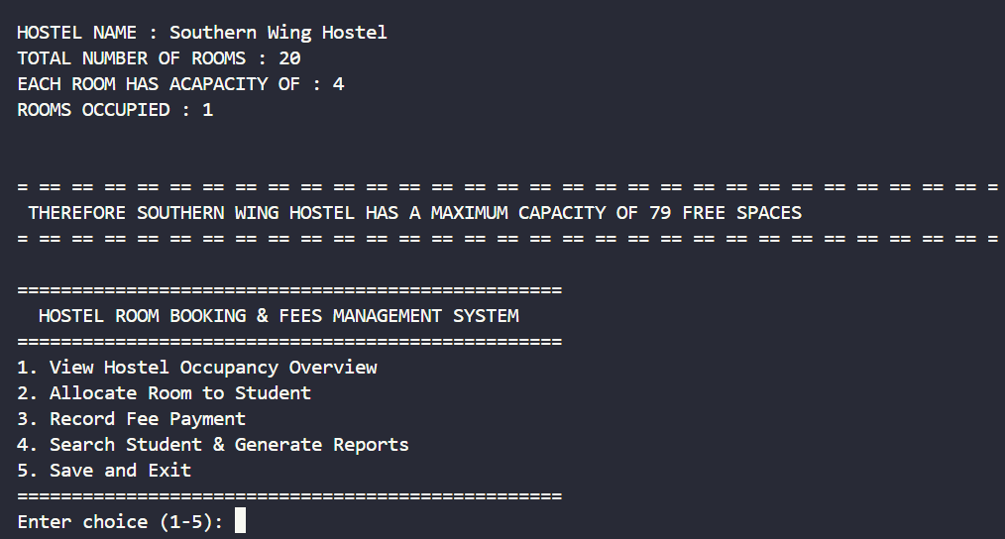
2.
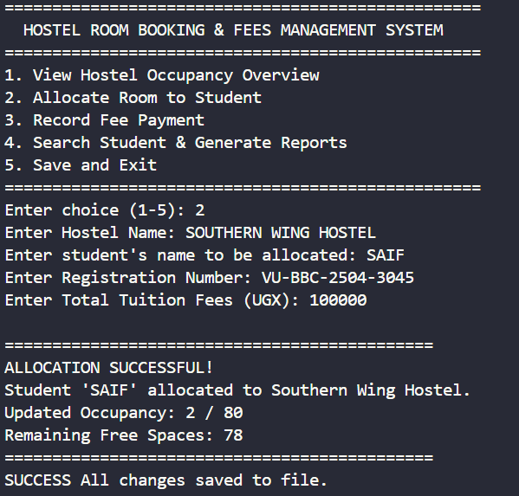

3.

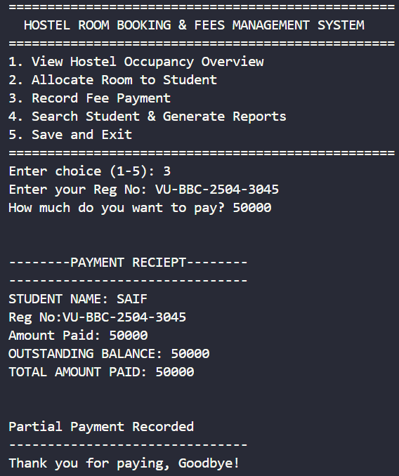

4.

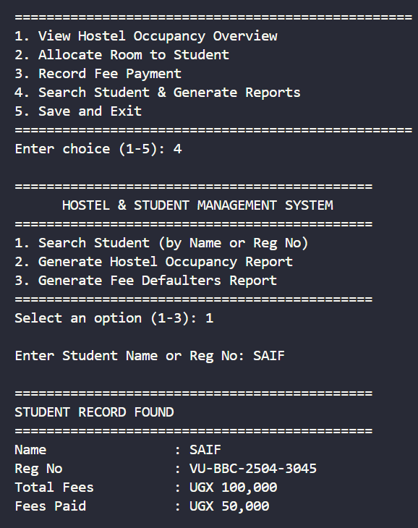
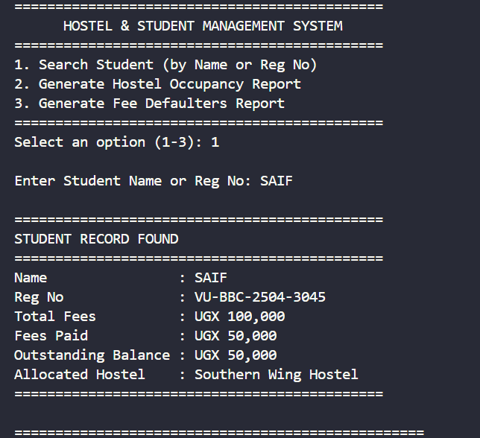5.
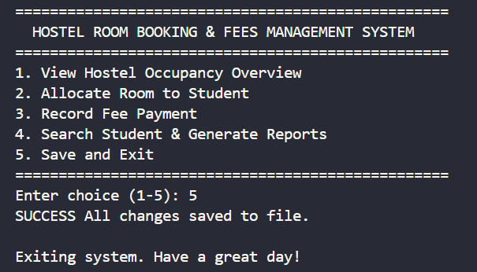

Conclusion
Our system successfully consolidates hostel room bookings, student registration, fee management, searching, reporting, and file persistence into a clean Python application. Dividing the work according to Parts A–F allowed members to specialize while Part F ensured full system integration.
GITHUB LINK []

GROUP MEMBERS NAMES AND REG.NO
NO. | PROG. | REGISTRATION NO. | FULL NAME
1 | BSF | VU-BSF-2603-2350-DAY | AMAR Mohamed Abdulkadir
2 | BSF | VU-BSF-2603-0398-DAY | SSAKA Dan Owen
3 | BIT | VU-BIT-2603-0361-DAY | URBAIN Kahonera Neville
4 | DIT | VU-DIT-2603-1490-DAY | MUGISHA Johnson Junior
5 | BSF | VU-BSF-2603-0542-DAY | NKWANGA Geofrey
6 | BSF | VU-BSF-2603-2001-DAY | ILUNGA Adonijah
7 | BSF | VU-BSF-2603-0413-DAY | NABUKENYA Jane Tracy
8 | BSF | VU-BSF-2603-1364-DAY | MBABAZI Racheal
9 | DIT | VU-DIT-2603-1523-DAY | TURYASIINGURA Godrick
10 | BCD | VU-BCD-2603-2174-DAY | NABUULE Agnes

